Task1:
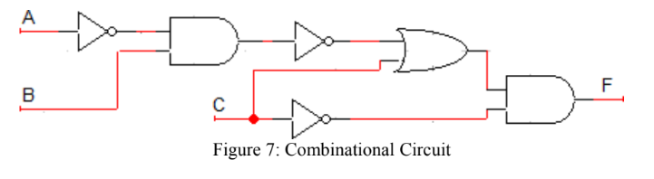
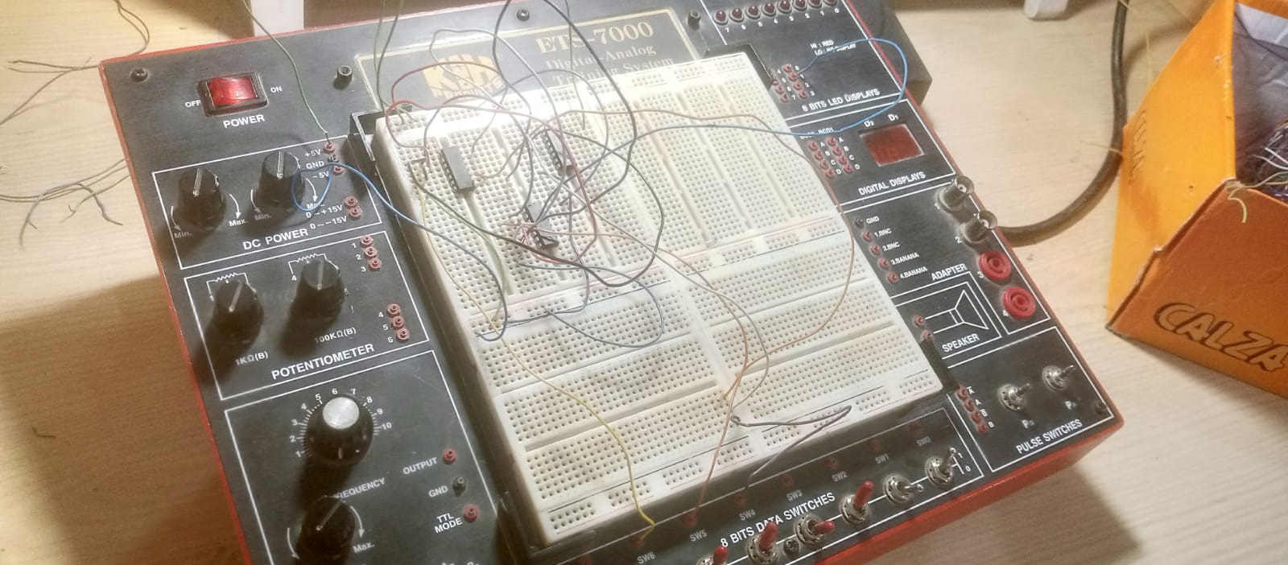
Boolean Expression:
F = ((A’.B)’+C).C’
Truth Table:
A | B | C | A' | A’ . B | (A ‘. B)’+C | C' | ((A’.B)’+C) . C'
0 | 0 | 0 | 1 | 0 | 1 | 1 | 1
0 | 0 | 1 | 1 | 0 | 1 | 0 | 0
0 | 1 | 0 | 1 | 1 | 0 | 1 | 0
0 | 1 | 1 | 1 | 1 | 1 | 0 | 0
1 | 0 | 0 | 0 | 0 | 1 | 1 | 1
1 | 0 | 1 | 0 | 0 | 1 | 0 | 0
1 | 1 | 0 | 0 | 0 | 1 | 1 | 1
1 | 1 | 1 | 0 | 0 | 1 | 0 | 0

Task 2 Part a:
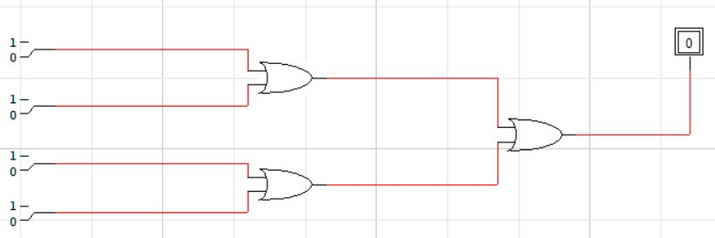
Boolean Expression:
F = A+B+C+D
Truth Table:
A | B | C | D | A + B | A + B + C | A + B + C + D
0 | 0 | 0 | 0 | 0 | 0 | 0
0 | 0 | 0 | 1 | 0 | 0 | 1
0 | 0 | 1 | 0 | 0 | 1 | 1
0 | 0 | 1 | 1 | 0 | 1 | 1
0 | 1 | 0 | 0 | 1 | 1 | 1
0 | 1 | 0 | 1 | 1 | 1 | 1
0 | 1 | 1 | 0 | 1 | 1 | 1
0 | 1 | 1 | 1 | 1 | 1 | 1
1 | 0 | 0 | 0 | 1 | 1 | 1
1 | 0 | 0 | 1 | 1 | 1 | 1
1 | 0 | 1 | 0 | 1 | 1 | 1
1 | 0 | 1 | 1 | 1 | 1 | 1
1 | 1 | 0 | 0 | 1 | 1 | 1
1 | 1 | 0 | 1 | 1 | 1 | 1
1 | 1 | 1 | 0 | 1 | 1 | 1
1 | 1 | 1 | 1 | 1 | 1 | 1

Task 2 Part b:
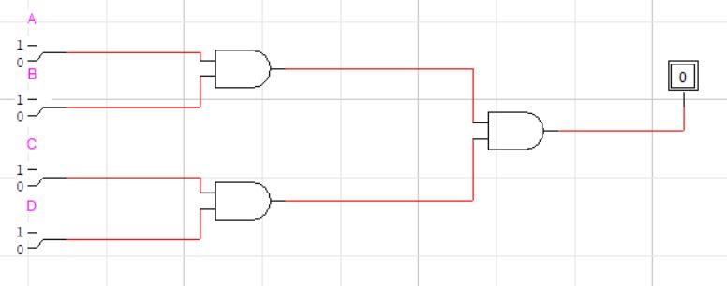

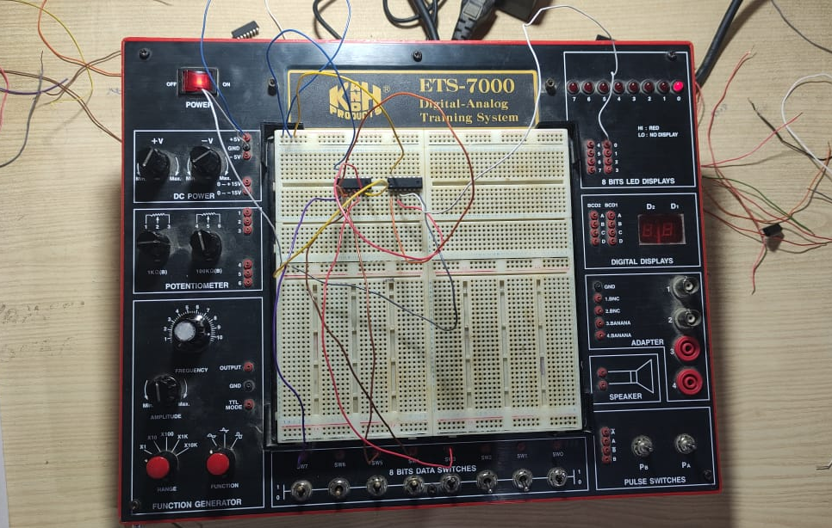
Boolean Expression:
F = A.B.C.D
Truth Table:
A | B | C | D | A.B | A.B.C | F
0 | 0 | 0 | 0 | 0 | 0 | 0
0 | 0 | 0 | 1 | 0 | 0 | 0
0 | 0 | 1 | 0 | 0 | 0 | 0
0 | 0 | 1 | 1 | 0 | 0 | 0
0 | 1 | 0 | 0 | 0 | 0 | 0
0 | 1 | 0 | 1 | 0 | 0 | 0
0 | 1 | 1 | 0 | 0 | 0 | 0
0 | 1 | 1 | 1 | 0 | 0 | 0
1 | 0 | 0 | 0 | 0 | 0 | 0
1 | 0 | 0 | 1 | 0 | 0 | 0
1 | 0 | 1 | 0 | 0 | 0 | 0
1 | 0 | 1 | 1 | 0 | 0 | 0
1 | 1 | 0 | 0 | 1 | 0 | 0
1 | 1 | 0 | 1 | 1 | 0 | 0
1 | 1 | 1 | 0 | 1 | 1 | 0
1 | 1 | 1 | 1 | 1 | 1 | 1

Task 2 Part C:
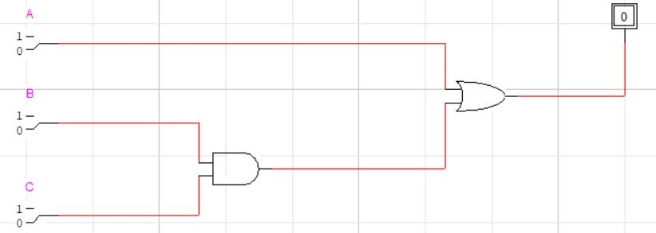
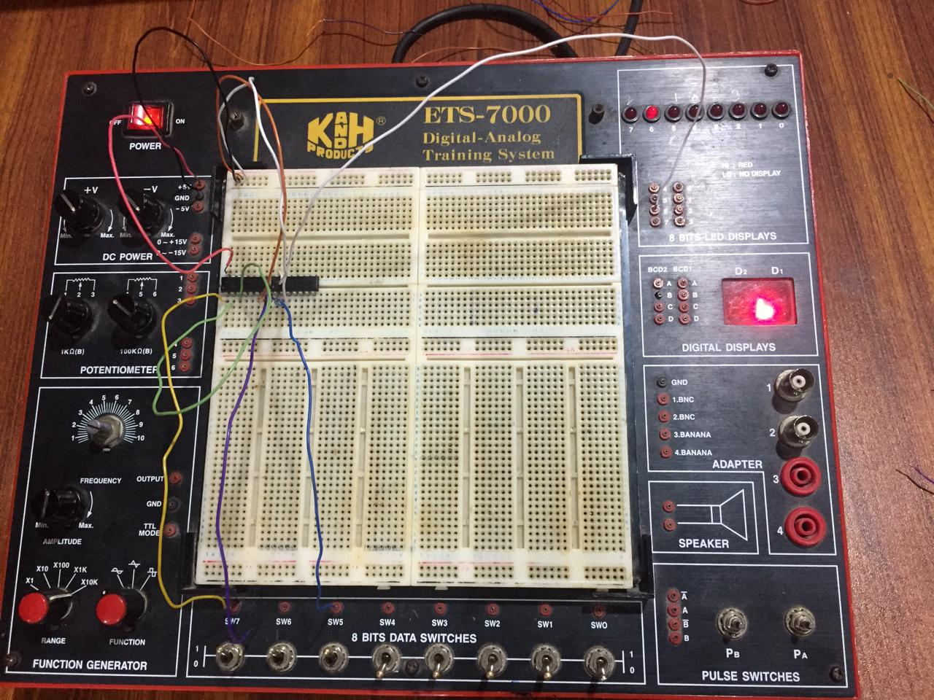
Boolean Expression:
F= A+BC
A | B | C | B.C | F
0 | 0 | 0 | 0 | 0
0 | 0 | 1 | 0 | 0
0 | 1 | 0 | 0 | 0
0 | 1 | 1 | 1 | 1
1 | 0 | 0 | 0 | 1
1 | 0 | 1 | 0 | 1
1 | 1 | 0 | 0 | 1
1 | 1 | 1 | 1 | 1

TASK 2 part d:
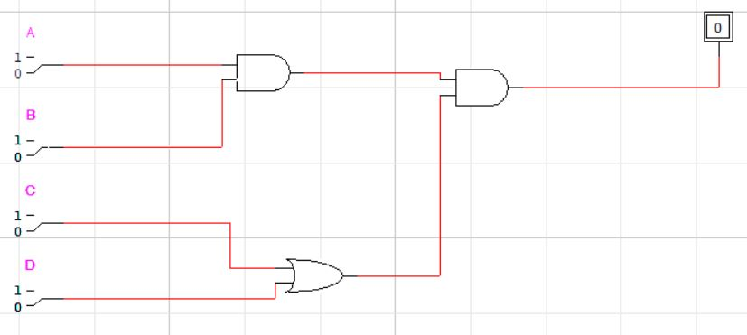
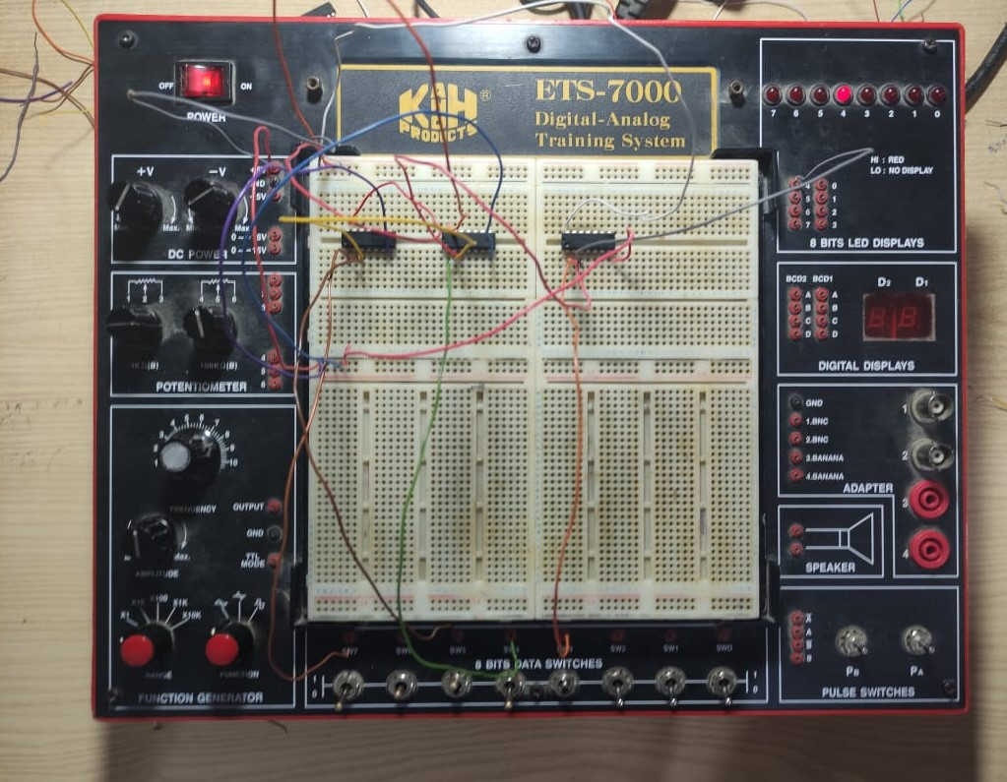

Boolean Expression:
F = (ABC+D)
Truth Table:
A | B | C | D | AB | ABC | F
0 | 0 | 0 | 0 | 0 | 0 | 0
0 | 0 | 0 | 1 | 0 | 0 | 1
0 | 0 | 1 | 0 | 0 | 0 | 0
0 | 0 | 1 | 1 | 0 | 0 | 1
0 | 1 | 0 | 0 | 0 | 0 | 0
0 | 1 | 0 | 1 | 0 | 0 | 1
0 | 1 | 1 | 0 | 0 | 0 | 0
0 | 1 | 1 | 1 | 0 | 0 | 1
1 | 0 | 0 | 0 | 0 | 0 | 0
1 | 0 | 0 | 1 | 0 | 0 | 1
1 | 0 | 1 | 0 | 0 | 0 | 0
1 | 0 | 1 | 1 | 0 | 0 | 1
1 | 1 | 0 | 0 | 1 | 0 | 0
1 | 1 | 0 | 1 | 1 | 0 | 1
1 | 1 | 1 | 0 | 1 | 1 | 1
1 | 1 | 1 | 1 | 1 | 1 | 1
Task 3:
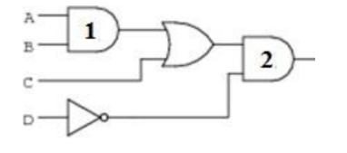
Expression:
F = (A.B +C).D’
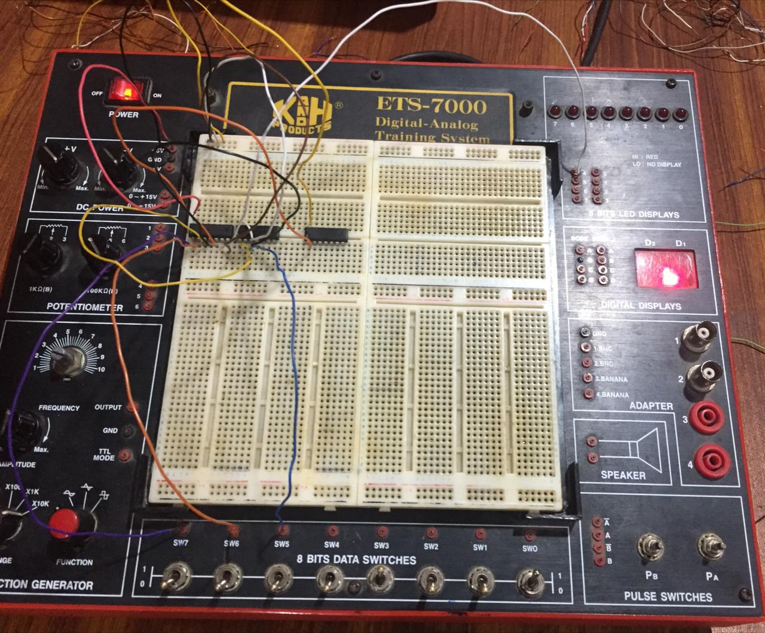

Truth Table:
A | B | C | D | AB | AB+C | F
0 | 0 | 0 | 0 | 0 | 0 | 0
0 | 0 | 0 | 1 | 0 | 0 | 0
0 | 0 | 1 | 0 | 0 | 1 | 1
0 | 0 | 1 | 1 | 0 | 1 | 1
0 | 1 | 0 | 0 | 0 | 0 | 0
0 | 1 | 0 | 1 | 0 | 0 | 0
0 | 1 | 1 | 0 | 0 | 1 | 1
0 | 1 | 1 | 1 | 0 | 1 | 1
1 | 0 | 0 | 0 | 0 | 0 | 0
1 | 0 | 0 | 1 | 0 | 0 | 0
1 | 0 | 1 | 0 | 0 | 1 | 1
1 | 0 | 1 | 1 | 0 | 1 | 0
1 | 1 | 0 | 0 | 1 | 1 | 1
1 | 1 | 0 | 1 | 1 | 1 | 1
1 | 1 | 1 | 0 | 1 | 1 | 1
1 | 1 | 1 | 1 | 1 | 1 | 0

